**FORMAN CHRISTIAN COLLEGE**

**(A CHARTERED UNIVERSITY)**



**Embedded Systems (CSCS 306)**

**FALL-2019**

**LAB-03**

**Arduino Programming with Keypad**

**Group Members:**

* Mohammad Usman 20-10558
* Haris Naseer 20-10612

**Introduction:**

The aim of the lab was to test our skills in dealing with a 4x4 keypad. It tested our coding skills, basically our logic in dealing with user input through keypad, processing it and displaying meaningful information. This lab consists of only one LabTask.

**LabTask:** In this LabTask, we had to use the Keypad library to interface with the keypad. On startup, we had to make an LED blink twice to indicate that the gas station terminal has started. Then, take 2 to 4 digits from the user through keypad with the submit button as the ‘#’ symbol. We converted the input string to integer and calculated total liters according to the given rate (Rs. 90 per liter). We display the total liters and wait for the amount of total liters (delay).

**Working Code:**

**LabTask:**

#include <Key.h>

#include <Keypad.h>

const byte rows = 4;

const byte cols = 4;

char keys[rows][cols] = {

{'1', '2', '3', 'A'},

{'4', '5', '6', 'B'},

{'7', '8', '9', 'C'},

{'*', '0', '#', 'D'}

};

byte rowPins[rows] = {6, 7, 8, 9};

byte colPins[cols] = {10, 11, 12, 13};

Keypad keypad = Keypad(makeKeymap(keys), rowPins, colPins, rows, cols);

int led = 2;

String amount = "";

int amt;

int iter = 0;

int amtDiv = 0;

void blink()

{

pinMode(led, OUTPUT);

for (int i=0; i<2; i++)

{

digitalWrite(led, HIGH);

delay(200);

digitalWrite(led, LOW);

delay(200);

}

}

void setup()

{

// put your setup code here, to run once:

Serial.begin(9600);

blink();

Serial.print("Enter amount: ");

}

void loop()

{

// put your main code here, to run repeatedly:

char key = keypad.getKey();

if (key != NO_KEY)

{

if (iter <= 4)

{

if (key != '#')

{

amount.concat(key);

iter++;

}

if (key == '#')

{

for (int i=0; i<iter; i++)

{

Serial.print(amount[i]);

}

Serial.println();

amt = amount.toInt();

amtDiv = amt / 90;

if (amt < 90)

{

Serial.println("Sorry, system cannot dispense fuel against this amount.");

}

else

{

Serial.print("You will have ");

Serial.print(amtDiv);

Serial.println(" Lit of fuel against this amount.");

Serial.println("Dispensing fuel. Please wait.");

delay(amtDiv * 1000);

}

Serial.println("Thank you for visiting us.");

Serial.println("Drive Safe.");

}

}

}

}

**Circuit Diagram:**

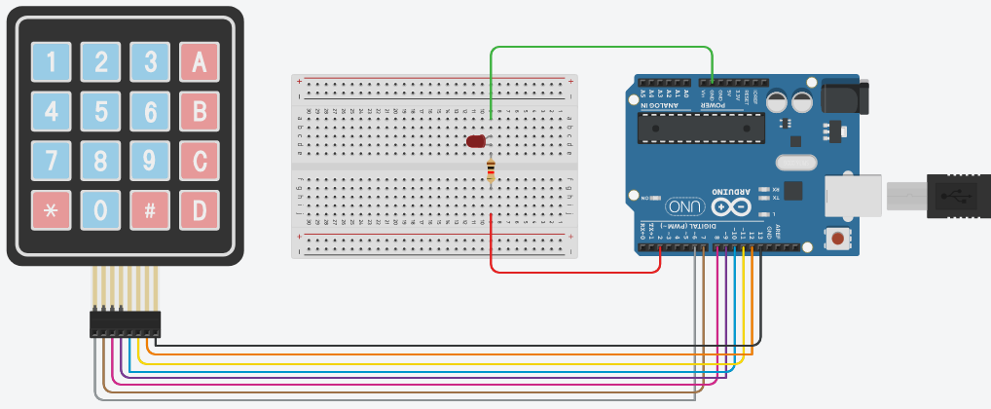

**Running Project Image:**

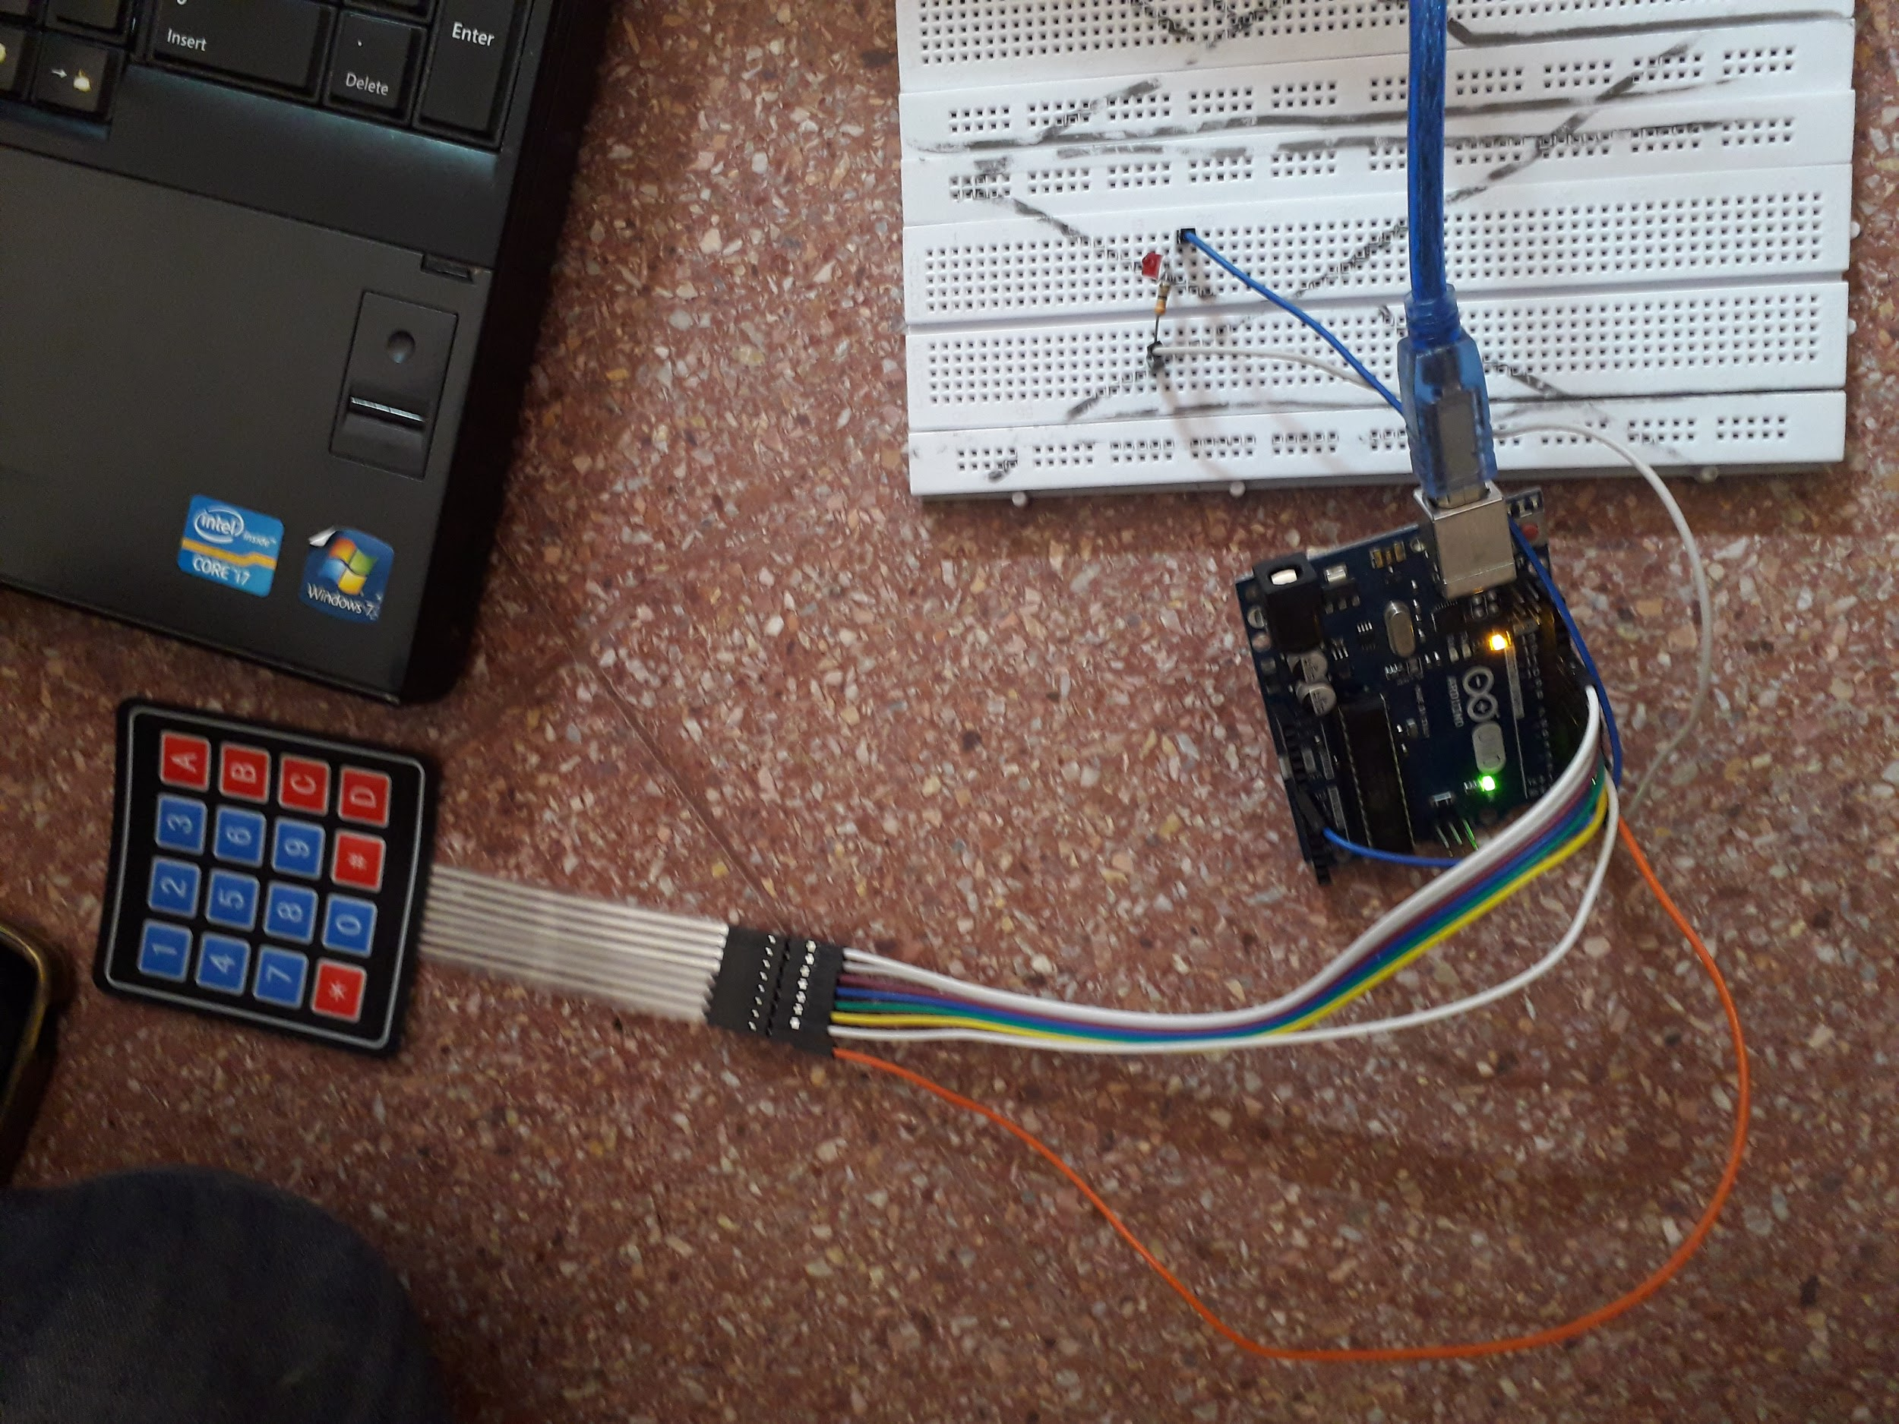

**Running Program Screenshots:**

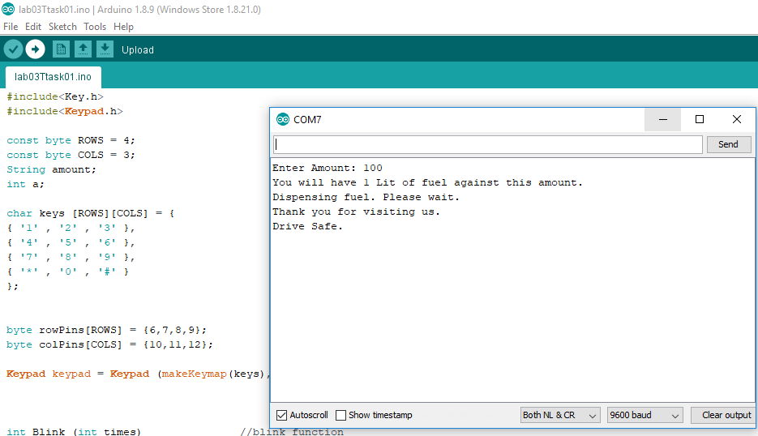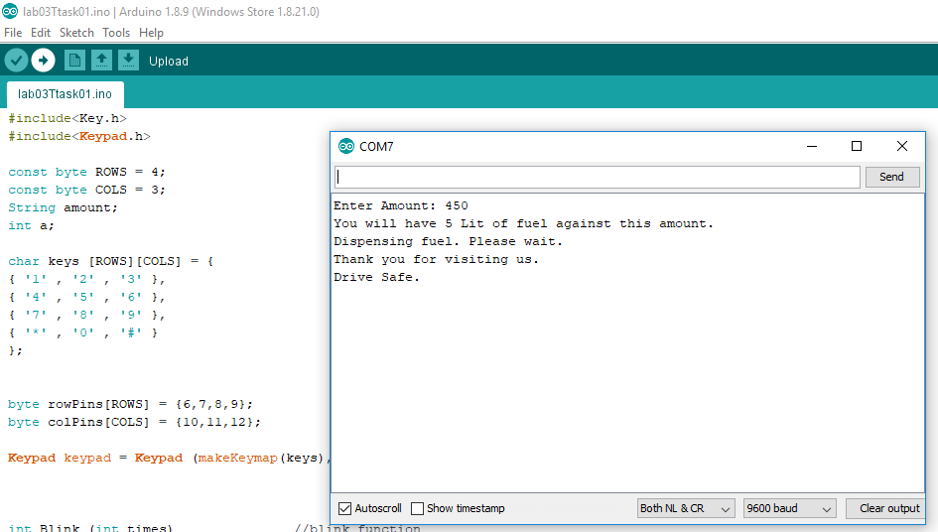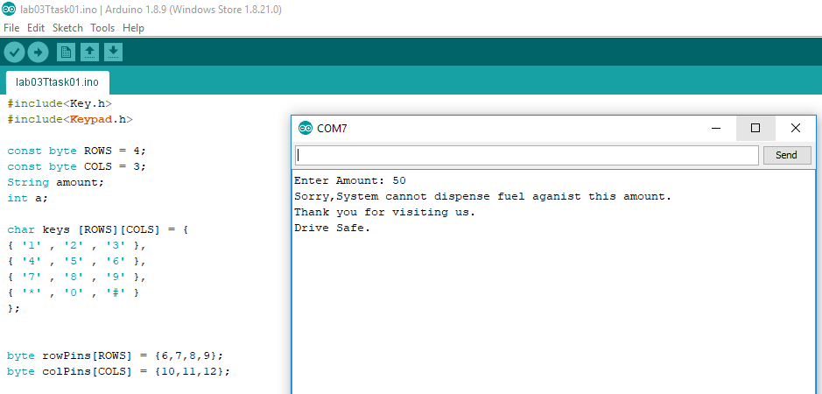

**References:**

* <https://www.arduino.cc/reference/en/language/functions/communication/serial/println/>
* <https://learn.adafruit.com/adafruit-arduino-lesson-2-leds/blinking-the-led>
* <https://playground.arduino.cc/code/keypad/>
* <https://www.arduino.cc/reference/en/language/variables/data-types/string/functions/concat/>
* <https://www.arduino.cc/en/Tutorial.StringToIntExample>
* <https://www.tinkercad.com>